**عملکرد عناصر همسو در ناحیه راه­انداز خانواده ژنی عوامل رونویسی MYB**

**The function of Cis elements in the promoter region of MYB transcription factors gene family**

|  |  |  |
| --- | --- | --- |
| **Name of motifs** | **sequence** | **Function** |
| ABRE | CACGTG | cis-acting element involved in the abscisic acid responsiveness |
| ABRE3a | TACGTG | cis-acting element involved in the abscisic acid responsiveness |
| ABRE4 | CACGTA | cis-acting element involved in the abscisic acid responsiveness |
| AT~ABRE | TACGTGTC | cis-acting element involved in the abscisic acid responsiveness |
| P-box | CCTTTTG | gibberellin-responsive element |
| TATC-box | TATCCCA | cis-acting element involved in gibberellin-responsiveness |
| GARE | _ | cis-acting element involved in gibberellin-responsiveness |
| TCA-element | CCATCTTTTT | cis-acting element involved in salicylic acid responsiveness |
| SARE | TTCGACCATCTT | cis-acting element involved in salicylic acid responsiveness |
| ERE | ATTTTAAA | Cis elements respond to ethylene |
| AuxRR-core | GGTCCAT | cis-acting regulatory element involved in auxin responsiveness |
| TGA-box | TGACGTAA | part of an auxin-responsive element |
| TGA-element | AACGAC | auxin-responsive element |
| AT-rich element | ATAGAAATCAA | binding site of AT-rich DNA binding protein (ATBP-1) |
| WRE3 | CCACCT | Elicitor-responsive cis-elements |
| box S | AGCCACC | wound-responsive element |
| W box | TTGACC | wound-responsive element |
| WUN-motif | TTATTACAT | wound-responsive element |
| MBS | CAACTG | MYB binding site involved in drought-inducibility |
| MYC | CATTTG | MYB binding site involved in drought-inducibility |
| DRE core | GCCGAC | MYB binding site involved in drought-inducibility |
| DRE1 | ACCGAGA | MYB binding site involved in drought-inducibility |
| MYB recognition site | CCGTTG | MYB binding site involved in drought-inducibility |
| MYB | _ | MYB binding site involved in drought-inducibility |
| AP-1 | TGAGTTAG | Cis elements respond to cadmium |
| LTR | CCGAAA | cis-acting element involved in low-temperature responsiveness |
| TC-rich repeats | GTTTTCTTAC | cis-acting element involved in defense and stress responsiveness |
| GC-motif | CCCCCG | enhancer-like element involved in anoxic specific inducibility |
| CARE | CAACTCAC | Cis-elements respond simultaneously to gibberellin and ABA |

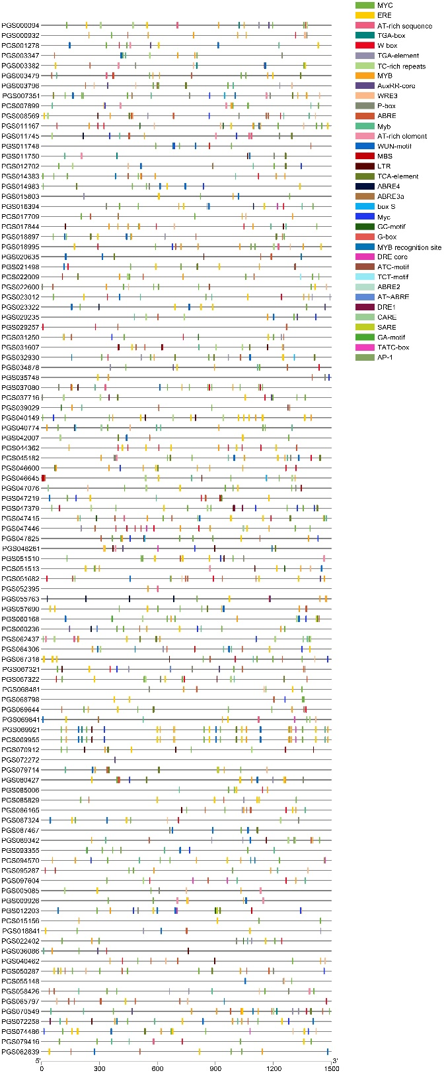

**شکل 1- نقشه طبقه‌بندی عناصر تنظیمی همسو خانواده ژنی MYB در سیب‌زمینی**

**Fig 1. Classification map of Cis regulatory elements of MYB gene family in potato**

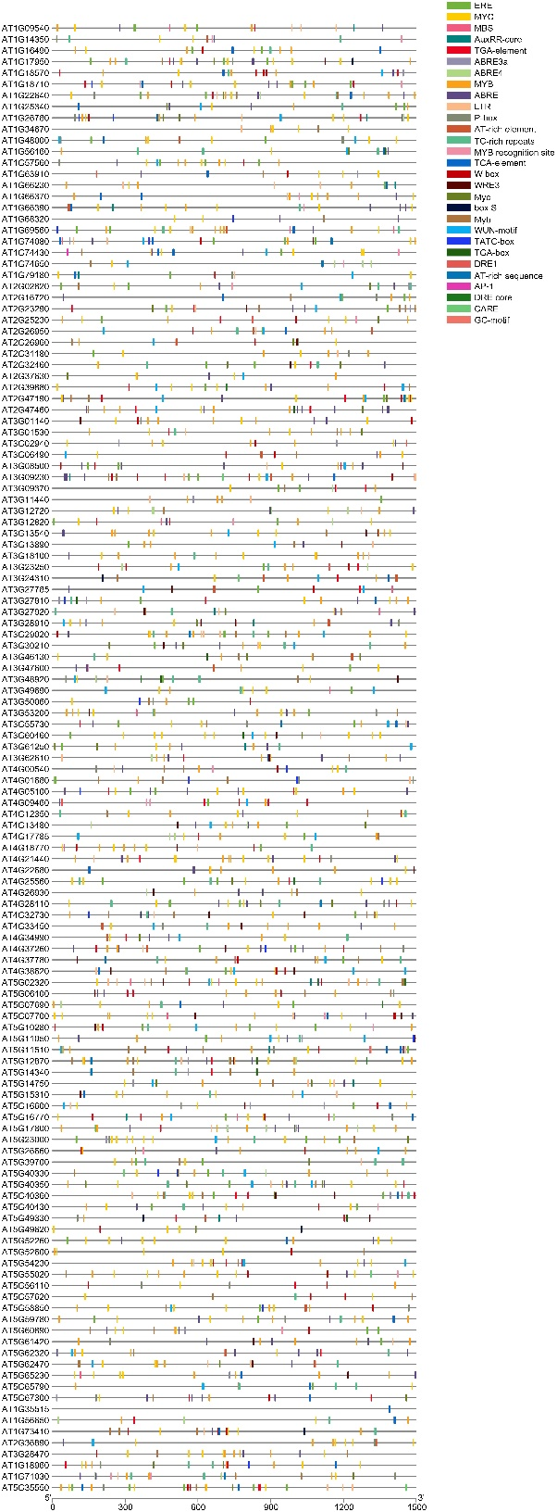

**شکل 2- نقشه طبقه‌بندی عناصر تنظیمی همسو خانواده ژنی MYB در آرابیدوپسیس**

**Fig 2. Classification map of Cis regulatory elements of MYB gene family in Arabidopsis**

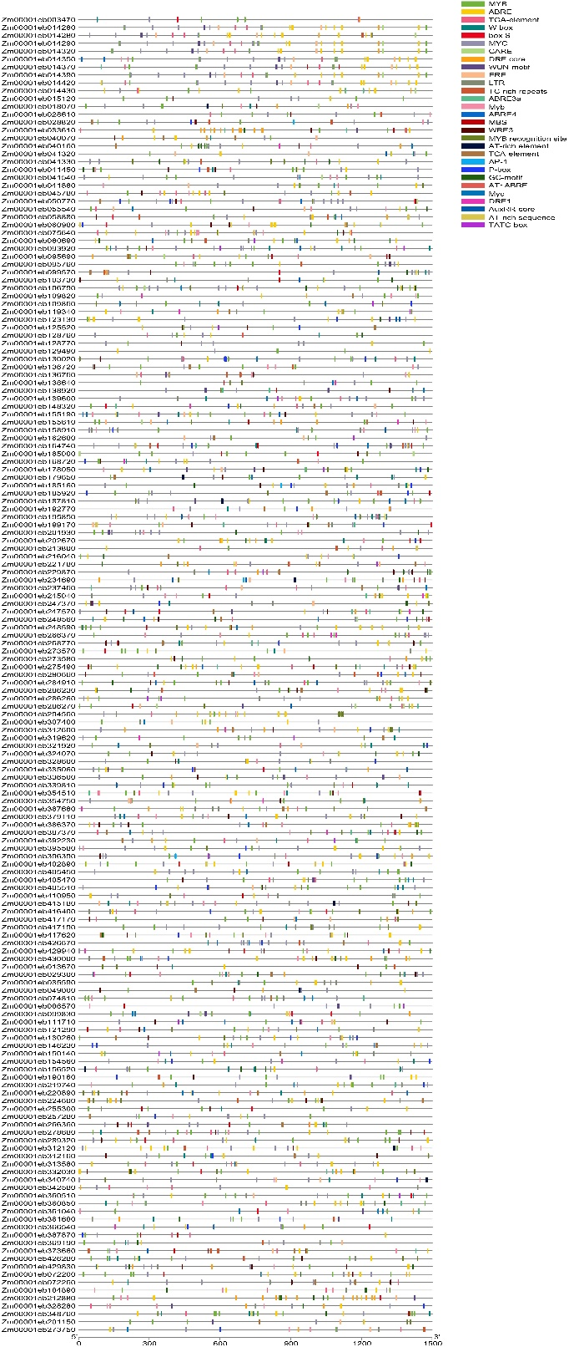

**شکل 3- نقشه طبقه‌بندی عناصر تنظیمی همسو خانواده ژنی MYB در ذرت**

**Fig 3. Classification map of Cis regulatory elements of MYB gene family in corn**

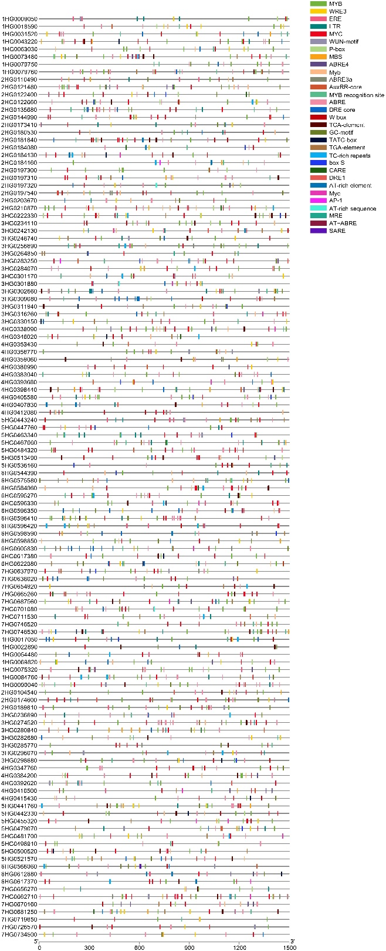

**شکل 4- نقشه طبقه‌بندی عناصر تنظیمی همسو خانواده ژنی MYB در جو**

**Fig 4. Classification map of Cis regulatory elements of MYB gene family in barley**