**جدول 1- مشخصات اعضای خانواده عوامل رونویسی MYB در سیب‌زمینی**

**Table 1. Characterization of MYB transcription factor family members in potato**

|  |  |  |  |  |
| --- | --- | --- | --- | --- |
| **Gene ID** | **Chr** | **Star pos** | **End pos** | **Groups** |
| PGS000094 | 1 | 71939878 | 71942036 | R2-MYB |
| PGS001883 | 1 | 86000524 | 86001549 | R2-MYB |
| PGS001924 | 1 | 86016239 | 86017645 | R2-MYB |
| PGS008515 | 1 | 74438212 | 74443032 | R2-MYB |
| PGS015803 | 1 | 87438016 | 87439876 | R2-MYB |
| PGS017709 | 1 | 65881546 | 65884345 | R2-MYB |
| PGS022600 | 1 | 36412167 | 36413918 | R2-MYB |
| PGS023322 | 1 | 62413414 | 62416529 | R2-MYB |
| PGS047076 | 1 | 79062872 | 79064724 | R2-MYB |
| PGS058426 | 1 | 5506259 | 5513285 | R2-MYB |
| PGS062437 | 1 | 52528914 | 52532078 | R2-MYB |
| PGS001278 | 2 | 47163131 | 47166949 | R2-MYB |
| PGS003347 | 2 | 46228350 | 46230096 | R2-MYB |
| PGS003382 | 2 | 46057853 | 46060165 | R2-MYB |
| PGS003479 | 2 | 45364428 | 45365322 | R2-MYB |
| PGS017844 | 2 | 25838187 | 25840887 | R2-MYB |
| PGS018897 | 2 | 37715819 | 37717148 | R2-MYB |
| PGS032930 | 2 | 47670219 | 47671556 | R2-MYB |
| PGS055148 | 2 | 42394491 | 42396025 | R2-MYB |
| PGS057690 | 2 | 35028804 | 35030478 | R2-MYB |
| PGS064306 | 2 | 43290372 | 43292067 | R2-MYB |
| PGS086891 | 2 | 38131603 | 38132672 | R2-MYB |
| PGS014383 | 3 | 58782540 | 58783899 | R2-MYB |
| PGS021498 | 3 | 37072195 | 37074087 | R2-MYB |
| PGS022009 | 3 | 18374336 | 18375366 | R2-MYB |
| PGS034878 | 3 | 637250 | 639778 | R2-MYB |
| PGS037080 | 3 | 42885406 | 42890857 | R2-MYB |
| PGS046600 | 3 | 52682806 | 52685051 | R2-MYB |
| PGS046645 | 3 | 52151311 | 52153379 | R2-MYB |
| PGS050287 | 3 | 55884819 | 55886615 | R2-MYB |
| PGS062839 | 3 | 53449065 | 53450718 | R1-MYB |
| PGS079714 | 3 | 44905092 | 44908245 | R2-MYB |
| PGS087467 | 3 | 61012748 | 61014172 | R2-MYB |
| PGS093355 | 3 | 37046944 | 37047994 | R2-MYB |
| PGS007336 | 4 | 235343 | 237238 | R2-MYB |
| PGS007351 | 4 | 342554 | 345766 | R2-MYB |
| PGS008569 | 4 | 67630129 | 67631587 | R2-MYB |
| PGS009450 | 4 | 69817779 | 69818545 | R2-MYB |
| PGS009583 | 4 | 69876006 | 69879916 | R2-MYB |
| PGS012702 | 4 | 66350883 | 66352780 | R2-MYB |
| PGS016394 | 4 | 63487743 | 63489452 | R2-MYB |
| PGS020635 | 4 | 68721298 | 68722349 | R2-MYB |
| PGS063862 | 4 | 57965342 | 57966851 | R2-MYB |
| PGS068798 | 4 | 3706322 | 3711165 | R2-MYB |
| PGS085006 | 4 | 47837158 | 47837760 | R2-MYB |
| PGS086475 | 4 | 35907903 | 35908324 | R2-MYB |
| PGS095287 | 4 | 48012409 | 48013464 | R2-MYB |
| PGS031250 | 5 | 11651239 | 11652540 | R2-MYB |
| PGS037716 | 5 | 3010226 | 3011701 | R2-MYB |
| PGS047379 | 5 | 4749905 | 4752350 | R2-MYB |
| PGS047415 | 5 | 4548155 | 4550928 | R2-MYB |
| PGS047446 | 5 | 4764169 | 4766317 | R2-MYB |
| PGS055763 | 5 | 43808357 | 43811048 | R2-MYB |
| PGS060168 | 5 | 50736152 | 50739653 | R2-MYB |
| PGS060236 | 5 | 50135192 | 50138300 | R2-MYB |
| PGS065797 | 5 | 5765092 | 5768126 | R2-MYB |
| PGS069841 | 5 | 48603078 | 48605136 | R2-MYB |
| PGS069921 | 5 | 48135780 | 48139477 | R2-MYB |
| PGS069955 | 5 | 48416600 | 48418300 | R2-MYB |
| PGS092914 | 5 | 10072559 | 10072900 | R2-MYB |
| PGS015156 | 6 | 54228199 | 54235466 | R2-MYB |
| PGS018841 | 6 | 108581 | 118710 | R2-MYB |
| PGS042007 | 6 | 39586222 | 39589448 | R2-MYB |
| PGS051510 | 6 | 35534084 | 35535099 | R2-MYB |
| PGS051513 | 6 | 35481835 | 35482790 | R2-MYB |
| PGS051682 | 6 | 58756763 | 58758225 | R2-MYB |
| PGS069644 | 6 | 52526603 | 52528380 | R2-MYB |
| PGS070912 | 6 | 35425405 | 35426734 | R2-MYB |
| PGS078128 | 6 | 57614588 | 57617481 | R2-MYB |
| PGS080427 | 6 | 46955194 | 46957388 | R2-MYB |
| PGS087324 | 6 | 52379865 | 52382096 | R2-MYB |
| PGS094570 | 6 | 57101142 | 57103475 | R2-MYB |
| PGS039029 | 7 | 48070254 | 48071746 | R2-MYB |
| PGS047219 | 7 | 48305719 | 48307269 | R2-MYB |
| PGS048261 | 7 | 2484435 | 2486834 | R2-MYB |
| PGS067318 | 7 | 47985794 | 47988263 | R2-MYB |
| PGS067321 | 7 | 47944406 | 47945391 | R2-MYB |
| PGS067322 | 7 | 47962766 | 47963967 | R2-MYB |
| PGS074486 | 7 | 46885787 | 46889699 | R2-MYB |
| PGS079416 | 7 | 4228845 | 4233200 | R2-MYB |
| PGS086165 | 7 | 48090733 | 48095332 | R2-MYB |
| PGS089342 | 7 | 56612161 | 56613114 | R2-MYB |
| PGS097604 | 7 | 48049050 | 48050133 | R2-MYB |
| PGS007899 | 8 | 54261364 | 54265845 | R3-MYB |
| PGS012203 | 8 | 52860791 | 52863242 | R2-MYB |
| PGS014983 | 8 | 5318295 | 5319957 | R2-MYB |
| PGS031607 | 8 | 56463901 | 56465212 | R2-MYB |
| PGS045182 | 8 | 49313407 | 49315050 | R2-MYB |
| PGS003796 | 9 | 57199959 | 57202781 | R2-MYB |
| PGS005085 | 9 | 6978461 | 6980244 | R2-MYB |
| PGS009926 | 9 | 5087875 | 5089659 | R2-MYB |
| PGS023012 | 9 | 1792941 | 1801007 | R3-MYB |
| PGS044362 | 9 | 56436850 | 56439237 | R2-MYB |
| PGS052395 | 9 | 750581 | 756745 | R2-MYB |
| PGS022402 | 10 | 824948 | 826717 | R2-MYB |
| PGS029235 | 10 | 633617 | 634572 | R2-MYB |
| PGS029257 | 10 | 530535 | 532180 | R2-MYB |
| PGS034372 | 10 | 47018167 | 47019454 | R2-MYB |
| PGS036284 | 10 | 51725169 | 51726374 | R2-MYB |
| PGS040774 | 10 | 18144786 | 18146378 | R2-MYB |
| PGS068481 | 10 | 4327840 | 4329933 | R2-MYB |
| PGS072258 | 10 | 56625972 | 56628457 | R2-MYB |
| PGS072272 | 10 | 56484441 | 56486409 | R2-MYB |
| PGS084268 | 10 | 44201932 | 44203180 | R2-MYB |
| PGS085829 | 10 | 44553310 | 44554508 | R2-MYB |
| PGS018995 | 11 | 38125207 | 38128456 | R2-MYB |
| PGS020790 | 11 | 41727337 | 41732481 | R2-MYB |
| PGS020979 | 11 | 40944871 | 40946417 | R2-MYB |
| PGS040149 | 11 | 45304491 | 45306368 | R2-MYB |
| PGS040462 | 11 | 1897631 | 1899791 | R1-MYB |
| PGS047825 | 11 | 42641555 | 42649265 | R3-MYB |
| PGS059543 | 11 | 30197216 | 30204698 | R2-MYB |
| PGS070549 | 11 | 43644994 | 43648125 | R2-MYB |
| PGS000932 | 12 | 3866192 | 3867733 | R2-MYB |
| PGS011167 | 12 | 52670915 | 52674965 | R2-MYB |
| PGS011745 | 12 | 59911547 | 59912674 | R2-MYB |
| PGS011748 | 12 | 59925024 | 59927050 | R2-MYB |
| PGS011750 | 12 | 59916609 | 59917573 | R2-MYB |
| PGS035748 | 12 | 6892243 | 6896589 | R2-MYB |
| PGS036086 | 12 | 6500640 | 6504467 | R2-MYB |
| PGS039974 | 12 | 56920755 | 56922436 | R2-MYB |

**جدول 2- مشخصات اعضای خانواده عوامل رونویسی MYB در ذرت**

**Table 2. Characterization of MYB transcription factor family members in corn**

|  |  |  |  |  |
| --- | --- | --- | --- | --- |
| **Gene ID** | **Chr** | **Star pos** | **End pos** | **Groups** |
| Zm003470_T001 | 1 | 9192133 | 9193586 | 2R-MYB |
| Zm010890_T001 | 1 | 34830530 | 34831057 | 2R-MYB |
| Zm013670_P001 | 1 | 45775586 | 45778291 | 2R-MYB |
| Zm014260_T001 | 1 | 47923929 | 47928862 | 2R-MYB |
| Zm014280_T001 | 1 | 47935437 | 47941623 | 2R-MYB |
| Zm014290_T001 | 1 | 47948490 | 47954508 | 2R-MYB |
| Zm014320_T001 | 1 | 47961449 | 47967174 | 2R-MYB |
| Zm014350_T001 | 1 | 47974272 | 47980360 | 2R-MYB |
| Zm014370_T001 | 1 | 47986957 | 47992977 | 2R-MYB |
| Zm014390_T001 | 1 | 47999589 | 48005301 | 2R-MYB |
| Zm014420_T001 | 1 | 48012326 | 48018226 | 2R-MYB |
| Zm014430_T001 | 1 | 48024552 | 48033273 | 2R-MYB |
| Zm015120_T001 | 1 | 51297898 | 51300218 | 2R-MYB |
| Zm018070_T001 | 1 | 64371137 | 64372984 | 2R-MYB |
| Zm028610_T001 | 1 | 152367682 | 152369855 | 2R-MYB |
| Zm028820_T004 | 1 | 154476509 | 154478109 | 2R-MYB |
| Zm029300_P001 | 1 | 158672333 | 158676799 | 2R-MYB |
| Zm033610_T002 | 1 | 186611059 | 186612481 | 2R-MYB |
| Zm035590_P001 | 1 | 194469822 | 194470961 | 2R-MYB |
| Zm040070_T001 | 1 | 211534896 | 211536302 | 2R-MYB |
| Zm040160_T001 | 1 | 211806186 | 211811544 | 2R-MYB |
| Zm041320_T001 | 1 | 217666913 | 217668553 | 2R-MYB |
| Zm041330_T001 | 1 | 217727302 | 217728789 | 2R-MYB |
| Zm041450_T001 | 1 | 218413248 | 218416660 | 2R-MYB |
| Zm041540_T001 | 1 | 218782726 | 218784769 | 2R-MYB |
| Zm041860_T001 | 1 | 220215475 | 220216993 | 1R-MYB |
| Zm045780_T001 | 1 | 236963527 | 236965946 | 2R-MYB |
| Zm049000_P002 | 1 | 251678210 | 251681292 | 2R-MYB |
| Zm050770_T002 | 1 | 258509093 | 258511643 | 2R-MYB |
| Zm055540_T001 | 1 | 276169671 | 276171672 | 2R-MYB |
| Zm058880_T001 | 1 | 288506872 | 288509069 | 2R-MYB |
| Zm060980_T001 | 1 | 295423285 | 295426271 | 2R-MYB |
| Zm064900_T001 | 1 | 306397748 | 306398322 | 2R-MYB |
| Zm072200_T002 | 2 | 13838408 | 13840151 | 1R-MYB |
| Zm072260_T001 | 2 | 13882924 | 13884461 | 1R-MYB |
| Zm074810_P001 | 2 | 21560394 | 21562253 | 2R-MYB |
| Zm075640_T001 | 2 | 24441782 | 24443806 | 2R-MYB |
| Zm080690_T001 | 2 | 43568184 | 43571134 | 2R-MYB |
| Zm085940_T001 | 2 | 77866255 | 77876530 | 2R-MYB |
| Zm086570_P001 | 2 | 85049882 | 85052953 | 2R-MYB |
| Zm093920_T002 | 2 | 156072875 | 156074158 | 2R-MYB |
| Zm095690_T001 | 2 | 168274815 | 168276647 | 2R-MYB |
| Zm095760_T002 | 2 | 168711390 | 168712901 | 2R-MYB |
| Zm099570_T002 | 2 | 186383867 | 186385420 | 2R-MYB |
| Zm099830_P001 | 2 | 187758522 | 187760043 | 2R-MYB |
| Zm103730_T001 | 2 | 202730800 | 202732191 | 2R-MYB |
| Zm106790_T001 | 2 | 211638635 | 211640465 | 2R-MYB |
| Zm109820_T004 | 2 | 219427428 | 219432383 | 2R-MYB |
| Zm109860_T001 | 2 | 219520230 | 219521902 | 2R-MYB |
| Zm111710_T001 | 2 | 224221614 | 224223318 | 2R-MYB |
| Zm119340_T002 | 3 | 2231146 | 2237222 | 3R-MYB |
| Zm121290_P001 | 3 | 6674549 | 6676738 | 2R-MYB |
| Zm123130_T001 | 3 | 13176780 | 13178157 | 2R-MYB |
| Zm123510_T001 | 3 | 14444415 | 14449138 | 2R-MYB |
| Zm125520_T001 | 3 | 23687239 | 23688978 | 2R-MYB |
| Zm128510_T001 | 3 | 41363821 | 41365106 | 2R-MYB |
| Zm128760_T001 | 3 | 43312858 | 43314123 | 2R-MYB |
| Zm128770_T001 | 3 | 43511364 | 43512428 | 2R-MYB |
| Zm129490_T001 | 3 | 48922348 | 48924785 | 2R-MYB |
| Zm130020_T001 | 3 | 52802108 | 52803319 | 1R-MYB |
| Zm130260_P001 | 3 | 54961178 | 54965222 | 2R-MYB |
| Zm136720_T001 | 3 | 128792139 | 128793690 | 2R-MYB |
| Zm136760_T001 | 3 | 129136771 | 129138807 | 2R-MYB |
| Zm138640_T001 | 3 | 140028666 | 140030766 | 2R-MYB |
| Zm138920_T001 | 3 | 141758915 | 141760104 | 2R-MYB |
| Zm139600_T001 | 3 | 145207627 | 145208688 | 2R-MYB |
| Zm146230_P001 | 3 | 178217240 | 178218693 | 2R-MYB |
| Zm148320_T001 | 3 | 185906104 | 185917627 | 3R-MYB |
| Zm150140_P001 | 3 | 192102234 | 192106236 | 2R-MYB |
| Zm154560_P001 | 3 | 207197815 | 207199653 | 2R-MYB |
| Zm155190_T002 | 3 | 209458510 | 209460788 | 2R-MYB |
| Zm155610_T001 | 3 | 210630723 | 210632377 | 2R-MYB |
| Zm156520_P001 | 3 | 213340716 | 213342311 | 2R-MYB |
| Zm158910_T001 | 3 | 221365129 | 221366555 | 2R-MYB |
| Zm158990_T001 | 3 | 221713437 | 221724829 | 2R-MYB |
| Zm162680_T001 | 3 | 233179317 | 233181943 | 2R-MYB |
| Zm164740_T001 | 4 | 1837797 | 1839174 | 2R-MYB |
| Zm165000_T003 | 4 | 2905504 | 2908201 | 2R-MYB |
| Zm168720_T001 | 4 | 15299300 | 15301857 | 2R-MYB |
| Zm170030_T001 | 4 | 22637076 | 22638469 | 2R-MYB |
| Zm178050_T001 | 4 | 26603871 | 26604570 | 2R-MYB |
| Zm179650_T001 | 4 | 86106705 | 86108595 | 2R-MYB |
| Zm184890_T001 | 4 | 145998532 | 145999661 | 1R-MYB |
| Zm185160_T001 | 4 | 147804262 | 147805807 | 2R-MYB |
| Zm185920_T001 | 4 | 153013525 | 153016310 | 1R-MYB |
| Zm187810_T001 | 4 | 162986784 | 162988536 | 2R-MYB |
| Zm190160_P001 | 4 | 171999050 | 172000478 | 2R-MYB |
| Zm192770_T001 | 4 | 180400346 | 180403198 | 2R-MYB |
| Zm195850_T001 | 4 | 191051305 | 191052874 | 2R-MYB |
| Zm199170_T001 | 4 | 203243104 | 203244314 | 2R-MYB |
| Zm201150_P001 | 4 | 213191112 | 213194425 | 1R-MYB |
| Zm201930_T001 | 4 | 217615806 | 217617737 | 2R-MYB |
| Zm202670_T001 | 4 | 223202328 | 223204408 | 2R-MYB |
| Zm212880_T001 | 5 | 4444783 | 4445878 | 1R-MYB |
| Zm213800_T001 | 5 | 5854700 | 5858635 | 2R-MYB |
| Zm216040_T001 | 5 | 10665158 | 10667170 | 2R-MYB |
| Zm218710_T003 | 5 | 17855941 | 17872567 | 2R-MYB |
| Zm219470_T001 | 5 | 20382125 | 20383115 | 2R-MYB |
| Zm219740_P001 | 5 | 21129197 | 21132120 | 2R-MYB |
| Zm220890_P001 | 5 | 25520986 | 25522144 | 2R-MYB |
| Zm221780_T001 | 5 | 29693525 | 29695578 | 2R-MYB |
| Zm222520_T002 | 5 | 33288176 | 33293506 | 2R-MYB |
| Zm224600_P004 | 5 | 43154988 | 43157571 | 2R-MYB |
| Zm229870_T001 | 5 | 71295333 | 71296908 | 2R-MYB |
| Zm234690_T001 | 5 | 100865469 | 100867079 | 2R-MYB |
| Zm237460_T001 | 5 | 137986868 | 138015382 | 4R-MYB |
| Zm244750_T001 | 5 | 179016302 | 179017425 | 2R-MYB |
| Zm245040_T001 | 5 | 180300047 | 180302092 | 2R-MYB |
| Zm247370_T001 | 5 | 189181793 | 189183636 | 2R-MYB |
| Zm247570_T001 | 5 | 190173305 | 190174659 | 2R-MYB |
| Zm248560_T001 | 5 | 192959147 | 192963649 | 2R-MYB |
| Zm248590_T001 | 5 | 193010373 | 193012573 | 2R-MYB |
| Zm252160_T001 | 5 | 209204832 | 209206116 | 2R-MYB |
| Zm255300_T001 | 5 | 216685538 | 216687228 | 2R-MYB |
| Zm256690_T009 | 5 | 220063974 | 220076020 | 2R-MYB |
| Zm257280_T001 | 5 | 220969206 | 220971776 | 2R-MYB |
| Zm266360_T001 | 6 | 42655721 | 42657418 | 2R-MYB |
| Zm266370_T001 | 6 | 42757910 | 42760236 | 2R-MYB |
| Zm268770_T001 | 6 | 66819689 | 66821668 | 2R-MYB |
| Zm273570_T001 | 6 | 98848289 | 98855912 | 2R-MYB |
| Zm273580_T001 | 6 | 98951685 | 98964845 | 2R-MYB |
| Zm273750_P001 | 6 | 100578377 | 100580639 | 1R-MYB |
| Zm275490_T001 | 6 | 107207628 | 107209723 | 2R-MYB |
| Zm278680_P001 | 6 | 119938912 | 119940552 | 2R-MYB |
| Zm280660_T001 | 6 | 128839472 | 128840857 | 1R-MYB |
| Zm284910_T002 | 6 | 146091731 | 146103864 | 3R-MYB |
| Zm286230_T001 | 6 | 151704676 | 151706551 | 2R-MYB |
| Zm286260_T001 | 6 | 151785088 | 151786454 | 2R-MYB |
| Zm286270_T001 | 6 | 151816536 | 151817444 | 2R-MYB |
| Zm289320_P001 | 6 | 161849746 | 161851001 | 2R-MYB |
| Zm294560_T001 | 6 | 173614872 | 173616800 | 2R-MYB |
| Zm296170_T001 | 6 | 176563304 | 176564688 | 2R-MYB |
| Zm296850_T001 | 6 | 177712798 | 177713774 | 2R-MYB |
| Zm307400_T001 | 7 | 52720492 | 52722060 | 2R-MYB |
| Zm312120_P001 | 7 | 113206300 | 113207743 | 2R-MYB |
| Zm312160_P001 | 7 | 113344773 | 113347282 | 2R-MYB |
| Zm312600_T001 | 7 | 117111316 | 117113348 | 2R-MYB |
| Zm313580_P002 | 7 | 124076015 | 124077813 | 2R-MYB |
| Zm319620_T001 | 7 | 149364659 | 149375517 | 2R-MYB |
| Zm321920_T001 | 7 | 156552270 | 156553956 | 2R-MYB |
| Zm324070_T001 | 7 | 166182515 | 166184346 | 2R-MYB |
| Zm328280_T003 | 7 | 176663838 | 176665966 | 1R-MYB |
| Zm328600_T001 | 7 | 177348968 | 177351359 | 2R-MYB |
| Zm332030_P001 | 7 | 185147528 | 185155361 | 2R-MYB |
| Zm334530_T001 | 8 | 8925665 | 8926768 | 2R-MYB |
| Zm335060_T001 | 8 | 11932475 | 11934336 | 2R-MYB |
| Zm336500_T001 | 8 | 17314670 | 17315820 | 2R-MYB |
| Zm337350_T002 | 8 | 20696876 | 20704663 | 2R-MYB |
| Zm339810_T001 | 8 | 34045580 | 34046836 | 2R-MYB |
| Zm340740_T001 | 8 | 41647480 | 41648637 | 2R-MYB |
| Zm342580_T001 | 8 | 64627703 | 64629170 | 2R-MYB |
| Zm344000_T001 | 8 | 72583413 | 72584803 | 2R-MYB |
| Zm348760_T001 | 8 | 103804659 | 103805922 | 1R-MYB |
| Zm350880_T001 | 8 | 116927851 | 116928941 | 2R-MYB |
| Zm354510_T001 | 8 | 132663488 | 132666012 | 2R-MYB |
| Zm354750_T001 | 8 | 133732393 | 133733817 | 2R-MYB |
| Zm359630_T001 | 8 | 152517880 | 152520450 | 2R-MYB |
| Zm359940_T001 | 8 | 153718452 | 153719681 | 2R-MYB |
| Zm360510_P001 | 8 | 155283445 | 155284801 | 2R-MYB |
| Zm360850_P001 | 8 | 156716457 | 156717363 | 2R-MYB |
| Zm361040_T001 | 8 | 157455928 | 157457489 | 2R-MYB |
| Zm361680_P001 | 8 | 159670916 | 159672316 | 2R-MYB |
| Zm366540_P001 | 8 | 172367546 | 172368797 | 2R-MYB |
| Zm367660_T002 | 8 | 174521739 | 174523879 | 2R-MYB |
| Zm367870_T001 | 8 | 175179321 | 175192414 | 3R-MYB |
| Zm369190_P001 | 8 | 177675625 | 177679776 | 2R-MYB |
| Zm373660_P001 | 9 | 11117066 | 11118378 | 2R-MYB |
| Zm375260_T001 | 9 | 16662214 | 16663540 | 2R-MYB |
| Zm379110_T001 | 9 | 28652737 | 28654621 | 2R-MYB |
| Zm386370_T001 | 9 | 95456371 | 95463300 | 2R-MYB |
| Zm387370_T001 | 9 | 101707433 | 101708732 | 2R-MYB |
| Zm392230_T001 | 9 | 124772082 | 124774904 | 2R-MYB |
| Zm395580_T001 | 9 | 139733687 | 139735904 | 2R-MYB |
| Zm396390_T001 | 9 | 142267452 | 142272128 | 2R-MYB |
| Zm402890_T001 | 9 | 158540780 | 158542467 | 2R-MYB |
| Zm405450_T001 | 10 | 2008367 | 2010928 | 2R-MYB |
| Zm405470_T001 | 10 | 2171060 | 2172216 | 2R-MYB |
| Zm405510_T001 | 10 | 2177185 | 2178084 | 2R-MYB |
| Zm410950_T001 | 10 | 29058975 | 29062146 | 2R-MYB |
| Zm415180_T001 | 10 | 75717760 | 75721585 | 2R-MYB |
| Zm416400_T001 | 10 | 82995786 | 82998409 | 2R-MYB |
| Zm417170_T001 | 10 | 87045298 | 87046925 | 2R-MYB |
| Zm417190_T001 | 10 | 87120080 | 87121522 | 2R-MYB |
| Zm417620_T002 | 10 | 89623826 | 89626979 | 2R-MYB |
| Zm424660_P001 | 10 | 126882091 | 126883776 | 2R-MYB |
| Zm426280_T001 | 10 | 132130383 | 132132508 | 2R-MYB |
| Zm426670_T001 | 10 | 133282790 | 133284965 | 2R-MYB |
| Zm429830_P001 | 10 | 141998557 | 142000623 | 2R-MYB |
| Zm429940_T001 | 10 | 142214302 | 142215629 | 2R-MYB |
| Zm430000_T001 | 10 | 142325860 | 142327622 | 2R-MYB |

**جدول 3- مشخصات اعضای خانواده عوامل رونویسی MYB در جو**

**Table 3. Characterization of MYB transcription factor family members in barley**

|  |  |  |  |  |
| --- | --- | --- | --- | --- |
| **Gene ID** | **Chr** | **Star pos** | **End pos** | **Groups** |
| 1HG0009050.1 | 1 | 21488716 | 21489588 | 2R-MYB |
| 1HG0017050.1 | 1 | 51806732 | 51807970 | 2R-MYB |
| 1HG0018590.1 | 1 | 61436701 | 61439073 | 2R-MYB |
| 1HG0022890.1 | 1 | 86724437 | 86735129 | 2R-MYB |
| 1HG0031520.1 | 1 | 156642522 | 156672396 | 3R-MYB |
| 1HG0043220.1 | 1 | 279275467 | 279277238 | 2R-MYB |
| 1HG0054480.1 | 1 | 364526364 | 364527821 | 2R-MYB |
| 1HG0063030.1 | 1 | 417402259 | 417403437 | 2R-MYB |
| 1HG0069820.2 | 1 | 448811751 | 448816808 | 2R-MYB |
| 1HG0073480.1 | 1 | 462813634 | 462823131 | 3R-MYB |
| 1HG0075320.1 | 1 | 471875012 | 471876280 | 2R-MYB |
| 1HG0079750.1 | 1 | 484817759 | 484819296 | 2R-MYB |
| 1HG0079760.1 | 1 | 484822662 | 484824213 | 2R-MYB |
| 1HG0084760.1 | 1 | 494674578 | 494676069 | 2R-MYB |
| 1HG0089600.1 | 1 | 503589523 | 503589789 | 2R-MYB |
| 1HG0089620.1 | 1 | 503602422 | 503602688 | 2R-MYB |
| 1HG0089650.1 | 1 | 503619485 | 503619751 | 2R-MYB |
| 1HG0089660.1 | 1 | 503623909 | 503624172 | 2R-MYB |
| 1HG0089690.1 | 1 | 503636029 | 503636295 | 2R-MYB |
| 1HG0089710.1 | 1 | 503640344 | 503641535 | 2R-MYB |
| 1HG0089740.1 | 1 | 503645102 | 503645365 | 2R-MYB |
| 1HG0090040.1 | 1 | 504430949 | 504431909 | 2R-MYB |
| 1HG0091980.1 | 1 | 508000019 | 508000794 | 2R-MYB |
| 1HG0091990.1 | 1 | 508013111 | 508013538 | 2R-MYB |
| 1HG0092140.1 | 1 | 508321620 | 508326136 | 2R-MYB |
| 2HG0104540.1 | 2 | 18060861 | 18064157 | 2R-MYB |
| 2HG0105310.1 | 2 | 20133992 | 20135076 | 2R-MYB |
| 2HG0110490.1 | 2 | 32910429 | 32911843 | 2R-MYB |
| 2HG0121480.1 | 2 | 77026892 | 77028856 | 2R-MYB |
| 2HG0122400.1 | 2 | 81910802 | 81912535 | 2R-MYB |
| 2HG0122660.1 | 2 | 83440285 | 83445481 | 2R-MYB |
| 2HG0135680.1 | 2 | 172121650 | 172123347 | 2R-MYB |
| 2HG0144990.1 | 2 | 256931486 | 256932810 | 2R-MYB |
| 2HG0173410.1 | 2 | 512087838 | 512090649 | 2R-MYB |
| 2HG0174600.1 | 2 | 520614641 | 520615895 | 2R-MYB |
| 2HG0180530.1 | 2 | 554022868 | 554025249 | 2R-MYB |
| 2HG0181840.1 | 2 | 559661961 | 559663910 | 2R-MYB |
| 2HG0184080.1 | 2 | 567980528 | 567982609 | 1R-MYB |
| 2HG0184130.1 | 2 | 568159301 | 568161611 | 2R-MYB |
| 2HG0184160.1 | 2 | 568413570 | 568414772 | 2R-MYB |
| 2HG0189810.1 | 2 | 596894172 | 596895785 | 2R-MYB |
| 2HG0197300.1 | 2 | 618362979 | 618364134 | 2R-MYB |
| 2HG0197310.1 | 2 | 618397750 | 618398826 | 2R-MYB |
| 2HG0197320.1 | 2 | 618413078 | 618414202 | 2R-MYB |
| 2HG0197540.1 | 2 | 618961471 | 618963331 | 2R-MYB |
| 2HG0203670.1 | 2 | 631997815 | 632017946 | 2R-MYB |
| 2HG0210870.1 | 2 | 649117117 | 649119347 | 2R-MYB |
| 3HG0222330.1 | 3 | 8469613 | 8471256 | 2R-MYB |
| 3HG0234110.1 | 3 | 34773428 | 34774393 | 2R-MYB |
| 3HG0236690.1 | 3 | 46212125 | 46213353 | 2R-MYB |
| 3HG0242130.1 | 3 | 82541043 | 82550741 | 2R-MYB |
| 3HG0248740.1 | 3 | 133370283 | 133377415 | 3R-MYB |
| 3HG0256690.1 | 3 | 199555309 | 199557194 | 2R-MYB |
| 3HG0264850.1 | 3 | 296413290 | 296414384 | 2R-MYB |
| 3HG0274520.1 | 3 | 388889243 | 388890285 | 2R-MYB |
| 3HG0277710.1 | 3 | 412941288 | 412941542 | 2R-MYB |
| 3HG0278050.1 | 3 | 415615594 | 415615848 | 2R-MYB |
| 3HG0280840.1 | 3 | 437081824 | 437083050 | 2R-MYB |
| 3HG0282680.1 | 3 | 449330127 | 449331182 | 2R-MYB |
| 3HG0283250.1 | 3 | 452743245 | 452744630 | 2R-MYB |
| 3HG0284070.1 | 3 | 457937810 | 457939626 | 2R-MYB |
| 3HG0285770.1 | 3 | 467276283 | 467277679 | 2R-MYB |
| 3HG0296070.1 | 3 | 522322816 | 522326687 | 2R-MYB |
| 3HG0298680.1 | 3 | 534488751 | 534490009 | 2R-MYB |
| 3HG0301170.1 | 3 | 544208100 | 544210278 | 2R-MYB |
| 3HG0301880.1 | 3 | 546878049 | 546882562 | 2R-MYB |
| 3HG0302660.1 | 3 | 549837719 | 549843800 | 3R-MYB |
| 3HG0308250.1 | 3 | 567126882 | 567133511 | 2R-MYB |
| 3HG0309080.1 | 3 | 569401789 | 569402682 | 2R-MYB |
| 3HG0311940.1 | 3 | 579228418 | 579231460 | 2R-MYB |
| 3HG0316260.1 | 3 | 589151905 | 589153736 | 2R-MYB |
| 3HG0330150.1 | 3 | 618139109 | 618140408 | 2R-MYB |
| 4HG0338090.1 | 4 | 21028810 | 21030092 | 2R-MYB |
| 4HG0346020.1 | 4 | 64657126 | 64659510 | 2R-MYB |
| 4HG0347760.1 | 4 | 79764017 | 79765541 | 2R-MYB |
| 4HG0353430.1 | 4 | 121079492 | 121080743 | 2R-MYB |
| 4HG0358770.1 | 4 | 164230768 | 164232141 | 2R-MYB |
| 4HG0359060.1 | 4 | 169011662 | 169012953 | 2R-MYB |
| 4HG0380990.1 | 4 | 417666916 | 417668403 | 2R-MYB |
| 4HG0383040.1 | 4 | 434648731 | 434653466 | 2R-MYB |
| 4HG0384200.1 | 4 | 446432676 | 446434471 | 2R-MYB |
| 4HG0392620.1 | 4 | 507033230 | 507034022 | 2R-MYB |
| 4HG0393680.1 | 4 | 514434052 | 514434765 | 2R-MYB |
| 4HG0398440.1 | 4 | 543096939 | 543097541 | 2R-MYB |
| 4HG0405580.1 | 4 | 571235912 | 571236921 | 2R-MYB |
| 4HG0407830.1 | 4 | 580348793 | 580349846 | 2R-MYB |
| 4HG0410500.1 | 4 | 589053514 | 589054618 | 2R-MYB |
| 4HG0412080.1 | 4 | 593375790 | 593376728 | 2R-MYB |
| 4HG0415430.1 | 4 | 602085760 | 602087165 | 2R-MYB |
| 5HG0428450.1 | 5 | 22051627 | 22055159 | 2R-MYB |
| 5HG0441760.1 | 5 | 90997613 | 91001175 | 2R-MYB |
| 5HG0442330.2 | 5 | 95710114 | 95711490 | 2R-MYB |
| 5HG0443240.1 | 5 | 103405912 | 103408018 | 2R-MYB |
| 5HG0447760.1 | 5 | 141063373 | 141065705 | 2R-MYB |
| 5HG0455320.1 | 5 | 240212782 | 240213891 | 2R-MYB |
| 5HG0463340.1 | 5 | 314757148 | 314758887 | 2R-MYB |
| 5HG0467660.1 | 5 | 345551346 | 345553267 | 2R-MYB |
| 5HG0479070.1 | 5 | 423978532 | 423979505 | 1R-MYB |
| 5HG0481700.1 | 5 | 438629365 | 438630402 | 2R-MYB |
| 5HG0484320.1 | 5 | 447977521 | 447978710 | 2R-MYB |
| 5HG0492890.1 | 5 | 484717931 | 484718194 | 2R-MYB |
| 5HG0492940.1 | 5 | 484726926 | 484727189 | 2R-MYB |
| 5HG0498910.1 | 5 | 499849744 | 499852748 | 2R-MYB |
| 5HG0500520.1 | 5 | 504537321 | 504538660 | 2R-MYB |
| 5HG0508400.1 | 5 | 521460477 | 521464498 | 2R-MYB |
| 5HG0513490.1 | 5 | 535077463 | 535079066 | 2R-MYB |
| 5HG0521570.1 | 5 | 552522376 | 552528377 | 3R-MYB |
| 5HG0536160.1 | 5 | 582913517 | 582914864 | 2R-MYB |
| 5HG0536400.1 | 5 | 583354216 | 583354500 | 2R-MYB |
| 6HG0544390.1 | 6 | 14632621 | 14634637 | 2R-MYB |
| 6HG0566060.1 | 6 | 98459291 | 98461147 | 2R-MYB |
| 6HG0575580.1 | 6 | 167414140 | 167415030 | 2R-MYB |
| 6HG0584060.1 | 6 | 248236867 | 248241623 | 1R-MYB |
| 6HG0595270.1 | 6 | 368295872 | 368297022 | 2R-MYB |
| 6HG0596330.1 | 6 | 376099149 | 376100280 | 2R-MYB |
| 6HG0596350.1 | 6 | 376234142 | 376235039 | 2R-MYB |
| 6HG0596410.1 | 6 | 376636473 | 376637207 | 2R-MYB |
| 6HG0596420.1 | 6 | 376675822 | 376676734 | 2R-MYB |
| 6HG0598590.1 | 6 | 394643499 | 394645874 | 2R-MYB |
| 6HG0598650.1 | 6 | 395097749 | 395099296 | 2R-MYB |
| 6HG0605830.1 | 6 | 453553504 | 453555109 | 2R-MYB |
| 6HG0612680.1 | 6 | 492301644 | 492302614 | 2R-MYB |
| 6HG0617370.1 | 6 | 516168007 | 516169205 | 2R-MYB |
| 6HG0617380.1 | 6 | 516268803 | 516270240 | 2R-MYB |
| 6HG0622080.1 | 6 | 532217107 | 532219329 | 2R-MYB |
| 7HG0637970.1 | 7 | 6598090 | 6599468 | 2R-MYB |
| 7HG0638020.1 | 7 | 6627742 | 6628806 | 2R-MYB |
| 7HG0654920.1 | 7 | 44708698 | 44710990 | 2R-MYB |
| 7HG0656270.1 | 7 | 49380778 | 49383201 | 2R-MYB |
| 7HG0662710.1 | 7 | 71236398 | 71238470 | 2R-MYB |
| 7HG0665260.1 | 7 | 85026240 | 85027379 | 2R-MYB |
| 7HG0670160.1 | 7 | 112332128 | 112333146 | 1R-MYB |
| 7HG0681250.1 | 7 | 185481599 | 185483685 | 2R-MYB |
| 7HG0687560.1 | 7 | 237909507 | 237910223 | 2R-MYB |
| 7HG0701080.1 | 7 | 393617557 | 393619314 | 2R-MYB |
| 7HG0711530.1 | 7 | 472893746 | 472895301 | 2R-MYB |
| 7HG0719850.1 | 7 | 526833306 | 526839286 | 2R-MYB |
| 7HG0724020.1 | 7 | 549178931 | 549180172 | 2R-MYB |
| 7HG0726570.1 | 7 | 562803159 | 562804028 | 2R-MYB |
| 7HG0734500.1 | 7 | 590204970 | 590206347 | 2R-MYB |
| 7HG0744480.1 | 7 | 613793592 | 613801649 | 2R-MYB |
| 7HG0744620.1 | 7 | 614028072 | 614029818 | 2R-MYB |
| 7HG0746520.1 | 7 | 617684864 | 617685733 | 2R-MYB |
| 7HG0746530.1 | 7 | 617694161 | 617695458 | 2R-MYB |

**جدول 4- مشخصات اعضای خانواده عوامل رونویسی MYB در آرابیدوپسیس**

**Table 4. Characterization of MYB transcription factor family members in Arabidopsis**

|  |  |  |  |  |
| --- | --- | --- | --- | --- |
| **Gene ID** | **Chr** | **Star pos** | **End pos** | **Groups** |
| AT1G06180.1 | 1 | 1889362 | 1891276 | 2R-MYB |
| AT1G08810.1 | 1 | 2819065 | 2820478 | 2R-MYB |
| AT1G09540.1 | 1 | 3086101 | 3087914 | 2R-MYB |
| AT1G14350.1 | 1 | 4907887 | 4911168 | 2R-MYB |
| AT1G16490.1 | 1 | 5629655 | 5631088 | 2R-MYB |
| AT1G17950.1 | 1 | 6177481 | 6179289 | 2R-MYB |
| AT1G18570.1 | 1 | 6389399 | 6391386 | 2R-MYB |
| AT1G18710.1 | 1 | 6450585 | 6453263 | 2R-MYB |
| AT1G18960.1 | 1 | 6552752 | 6554036 | 1R-MYB |
| AT1G22640.1 | 1 | 8006064 | 8007465 | 2R-MYB |
| AT1G25340.3 | 1 | 8885020 | 8886777 | 1R-MYB |
| AT1G26780.2 | 1 | 9270952 | 9272713 | 2R-MYB |
| AT1G34670.1 | 1 | 12709090 | 12710665 | 2R-MYB |
| AT1G35515.1 | 1 | 13077890 | 13080265 | 2R-MYB |
| AT1G48000.1 | 1 | 17704132 | 17706460 | 2R-MYB |
| AT1G49950.1 | 1 | 18494029 | 18497318 | 2R-MYB |
| AT1G56160.1 | 1 | 21022384 | 21023587 | 2R-MYB |
| AT1G56650.1 | 1 | 21233555 | 21235292 | 1R-MYB |
| AT1G57560.1 | 1 | 21316730 | 21318192 | 2R-MYB |
| AT1G63910.1 | 1 | 23719783 | 23721774 | 2R-MYB |
| AT1G66230.1 | 1 | 24677121 | 24678580 | 1R-MYB |
| AT1G66370.1 | 1 | 24753589 | 24754761 | 2R-MYB |
| AT1G66390.1 | 1 | 24763941 | 24765541 | 2R-MYB |
| AT1G68320.1 | 1 | 25603676 | 25605181 | 2R-MYB |
| AT1G69560.2 | 1 | 26157702 | 26159094 | 2R-MYB |
| AT1G71030.1 | 1 | 26795052 | 26796532 | 1R-MYB |
| AT1G73410.1 | 1 | 27601593 | 27603317 | 2R-MYB |
| AT1G74080.1 | 1 | 27855578 | 27857598 | 2R-MYB |
| AT1G74430.1 | 1 | 27975168 | 27977434 | 2R-MYB |
| AT1G74650.1 | 1 | 28041146 | 28043022 | 2R-MYB |
| AT1G79180.2 | 1 | 29786257 | 29787820 | 2R-MYB |
| AT2G02820.2 | 2 | 803656 | 807895 | 2R-MYB |
| AT2G16720.1 | 2 | 7255473 | 7256831 | 2R-MYB |
| AT2G18328.1 | 2 | 7964326 | 7964995 | 2R-MYB |
| AT2G23290.1 | 2 | 9904506 | 9906032 | 2R-MYB |
| AT2G25230.1 | 2 | 10747211 | 10748467 | 2R-MYB |
| AT2G26950.1 | 2 | 11500721 | 11502136 | 2R-MYB |
| AT2G26960.1 | 2 | 11506065 | 11507426 | 2R-MYB |
| AT2G30420.1 | 2 | 12960847 | 12962162 | 2R-MYB |
| AT2G31180.1 | 2 | 13286681 | 13288380 | 2R-MYB |
| AT2G32460.1 | 2 | 13782107 | 13784483 | 2R-MYB |
| AT2G36890.2 | 2 | 15485619 | 15487451 | 2R-MYB |
| AT2G37630.1 | 2 | 15781232 | 15783480 | 2R-MYB |
| AT2G39880.1 | 2 | 16647711 | 16649527 | 2R-MYB |
| AT2G47190.1 | 2 | 19375985 | 19377543 | 2R-MYB |
| AT2G47460.1 | 2 | 19476326 | 19479597 | 2R-MYB |
| AT3G01140.1 | 3 | 46330 | 48296 | 2R-MYB |
| AT3G01530.1 | 3 | 210119 | 211804 | 2R-MYB |
| AT3G02940.1 | 3 | 661849 | 664011 | 2R-MYB |
| AT3G06490.1 | 3 | 2003393 | 2006727 | 2R-MYB |
| AT3G08500.1 | 3 | 2576444 | 2578276 | 2R-MYB |
| AT3G09230.1 | 3 | 2833346 | 2835390 | 2R-MYB |
| AT3G09370.1 | 3 | 2879353 | 2882396 | 3R-MYB |
| AT3G11440.1 | 3 | 3602036 | 3605172 | 2R-MYB |
| AT3G12720.1 | 3 | 4043288 | 4044715 | 2R-MYB |
| AT3G12820.1 | 3 | 4073855 | 4075643 | 2R-MYB |
| AT3G13540.1 | 3 | 4419960 | 4421751 | 2R-MYB |
| AT3G13890.1 | 3 | 4576193 | 4578082 | 2R-MYB |
| AT3G18100.1 | 3 | 6200524 | 6204752 | 3R-MYB |
| AT3G23250.1 | 3 | 8309209 | 8310910 | 2R-MYB |
| AT3G24310.1 | 3 | 8811011 | 8812483 | 2R-MYB |
| AT3G27785.1 | 3 | 10288603 | 10290934 | 2R-MYB |
| AT3G27810.1 | 3 | 10305849 | 10310492 | 2R-MYB |
| AT3G27920.1 | 3 | 10361790 | 10363607 | 2R-MYB |
| AT3G28470.1 | 3 | 10674508 | 10675724 | 2R-MYB |
| AT3G28910.1 | 3 | 10911132 | 10913190 | 2R-MYB |
| AT3G29020.2 | 3 | 11008079 | 11009456 | 2R-MYB |
| AT3G30210.1 | 3 | 11838363 | 11840502 | 2R-MYB |
| AT3G46130.1 | 3 | 16945230 | 16946699 | 2R-MYB |
| AT3G47600.1 | 3 | 17539289 | 17541307 | 2R-MYB |
| AT3G48920.1 | 3 | 18139172 | 18140772 | 2R-MYB |
| AT3G49690.1 | 3 | 18427735 | 18429281 | 2R-MYB |
| AT3G50060.1 | 3 | 18557607 | 18559326 | 2R-MYB |
| AT3G53200.1 | 3 | 19718253 | 19719507 | 2R-MYB |
| AT3G55730.1 | 3 | 20681827 | 20684063 | 2R-MYB |
| AT3G60460.1 | 3 | 22342321 | 22343576 | 2R-MYB |
| AT3G61250.1 | 3 | 22670729 | 22672751 | 2R-MYB |
| AT3G62610.1 | 3 | 23154630 | 23156585 | 2R-MYB |
| AT4G00540.1 | 4 | 234597 | 237582 | 3R-MYB |
| AT4G01680.2 | 4 | 715970 | 717603 | 2R-MYB |
| AT4G05100.1 | 4 | 2618372 | 2619947 | 2R-MYB |
| AT4G09460.1 | 4 | 5992908 | 5994258 | 2R-MYB |
| AT4G12350.1 | 4 | 7324756 | 7326867 | 2R-MYB |
| AT4G13480.1 | 4 | 7836644 | 7837763 | 2R-MYB |
| AT4G17785.1 | 4 | 9881599 | 9883432 | 2R-MYB |
| AT4G18770.1 | 4 | 10311030 | 10313104 | 2R-MYB |
| AT4G21440.1 | 4 | 11418199 | 11419769 | 2R-MYB |
| AT4G22680.1 | 4 | 11922340 | 11924230 | 2R-MYB |
| AT4G25560.1 | 4 | 13052503 | 13053742 | 2R-MYB |
| AT4G26930.1 | 4 | 13527578 | 13529429 | 2R-MYB |
| AT4G28110.1 | 4 | 13968029 | 13969525 | 2R-MYB |
| AT4G32730.2 | 4 | 15790133 | 15796114 | 3R-MYB |
| AT4G33450.1 | 4 | 16095392 | 16096774 | 2R-MYB |
| AT4G34990.1 | 4 | 16661101 | 16662549 | 2R-MYB |
| AT4G36570.1 | 4 | 17254290 | 17255762 | 2R-MYB |
| AT4G37260.1 | 4 | 17540490 | 17541799 | 2R-MYB |
| AT4G37780.1 | 4 | 17758232 | 17759746 | 2R-MYB |
| AT4G38620.1 | 4 | 18053360 | 18055040 | 2R-MYB |
| AT4G39250.1 | 4 | 18271198 | 18272129 | 2R-MYB |
| AT5G02320.1 | 5 | 482793 | 486473 | 3R-MYB |
| AT5G06100.2 | 5 | 1837835 | 1840727 | 2R-MYB |
| AT5G06110.1 | 5 | 1840755 | 1843872 | 2R-MYB |
| AT5G07690.1 | 5 | 2446669 | 2448584 | 2R-MYB |
| AT5G07700.1 | 5 | 2450027 | 2451807 | 2R-MYB |
| AT5G10280.1 | 5 | 3232569 | 3234277 | 2R-MYB |
| AT5G11050.1 | 5 | 3502092 | 3503834 | 2R-MYB |
| AT5G11510.1 | 5 | 3679748 | 3684884 | 3R-MYB |
| AT5G12870.1 | 5 | 4062666 | 4065075 | 2R-MYB |
| AT5G14340.1 | 5 | 4623198 | 4624960 | 2R-MYB |
| AT5G14750.1 | 5 | 4763372 | 4764834 | 2R-MYB |
| AT5G15310.1 | 5 | 4974671 | 4976470 | 2R-MYB |
| AT5G16600.1 | 5 | 5438165 | 5440433 | 2R-MYB |
| AT5G16770.2 | 5 | 5514717 | 5517153 | 2R-MYB |
| AT5G17800.1 | 5 | 5877113 | 5879331 | 2R-MYB |
| AT5G23000.1 | 5 | 7696135 | 7698022 | 2R-MYB |
| AT5G26660.1 | 5 | 9331565 | 9333284 | 2R-MYB |
| AT5G35550.2 | 5 | 13726743 | 13727961 | 1R-MYB |
| AT5G39700.1 | 5 | 15893761 | 15894424 | 2R-MYB |
| AT5G40330.1 | 5 | 16127725 | 16129661 | 2R-MYB |
| AT5G40350.1 | 5 | 16138544 | 16141134 | 2R-MYB |
| AT5G40360.1 | 5 | 16144792 | 16146671 | 2R-MYB |
| AT5G40430.1 | 5 | 16176427 | 16177731 | 2R-MYB |
| AT5G49330.1 | 5 | 19998823 | 20001572 | 2R-MYB |
| AT5G49620.2 | 5 | 20137214 | 20139609 | 2R-MYB |
| AT5G52260.1 | 5 | 21220031 | 21221288 | 2R-MYB |
| AT5G52600.1 | 5 | 21343102 | 21344106 | 2R-MYB |
| AT5G54230.1 | 5 | 22016143 | 22018061 | 2R-MYB |
| AT5G55020.1 | 5 | 22324599 | 22326418 | 2R-MYB |
| AT5G56110.1 | 5 | 22719191 | 22720664 | 2R-MYB |
| AT5G57620.1 | 5 | 23334767 | 23336632 | 2R-MYB |
| AT5G58850.1 | 5 | 23763945 | 23765556 | 2R-MYB |
| AT5G59780.3 | 5 | 24081868 | 24083562 | 2R-MYB |
| AT5G60890.1 | 5 | 24494291 | 24496371 | 2R-MYB |
| AT5G61420.2 | 5 | 24689069 | 24691187 | 2R-MYB |
| AT5G62320.1 | 5 | 25028716 | 25029933 | 2R-MYB |
| AT5G62470.2 | 5 | 25078991 | 25081141 | 2R-MYB |
| AT5G65230.1 | 5 | 26068112 | 26069652 | 2R-MYB |
| AT5G65790.1 | 5 | 26322817 | 26324609 | 2R-MYB |
| AT5G67300.1 | 5 | 26854022 | 26856006 | 2R-MYB |

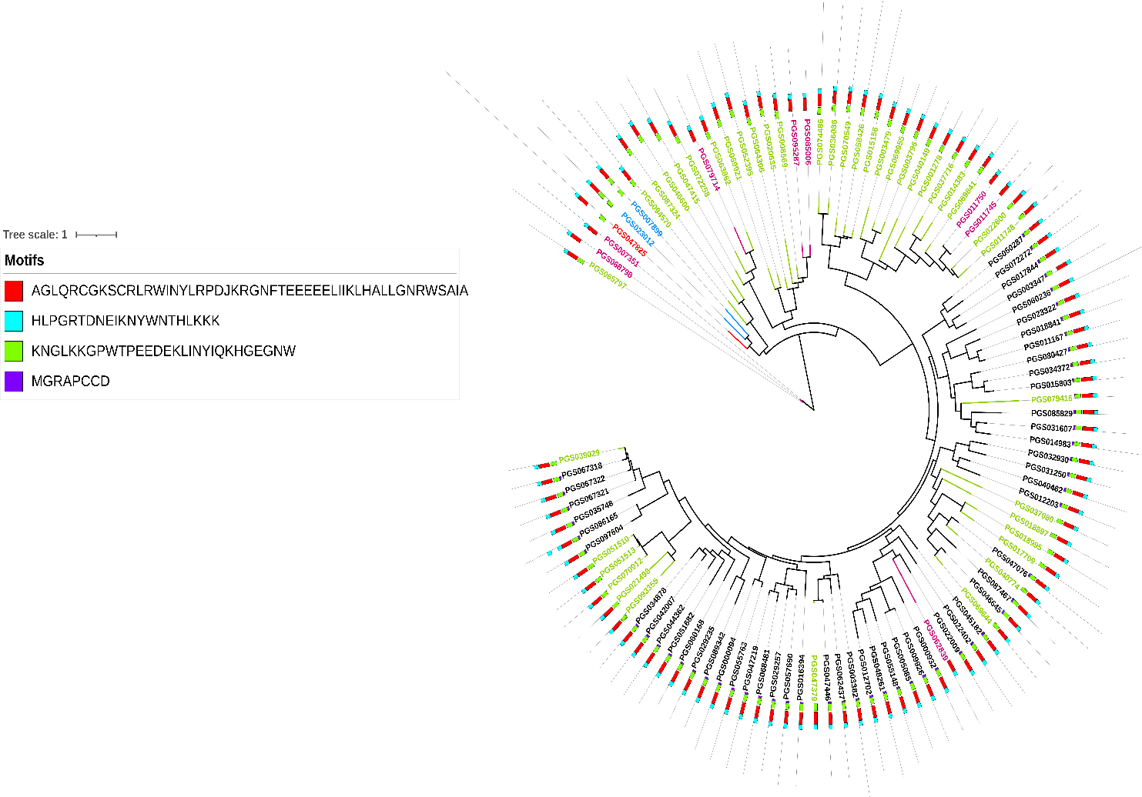

**درخت فیلوژنتیک خانواده ژنی MYB در گیاه سیب‌زمینی**

**Phylogenetic tree of MYB gene family in potato**

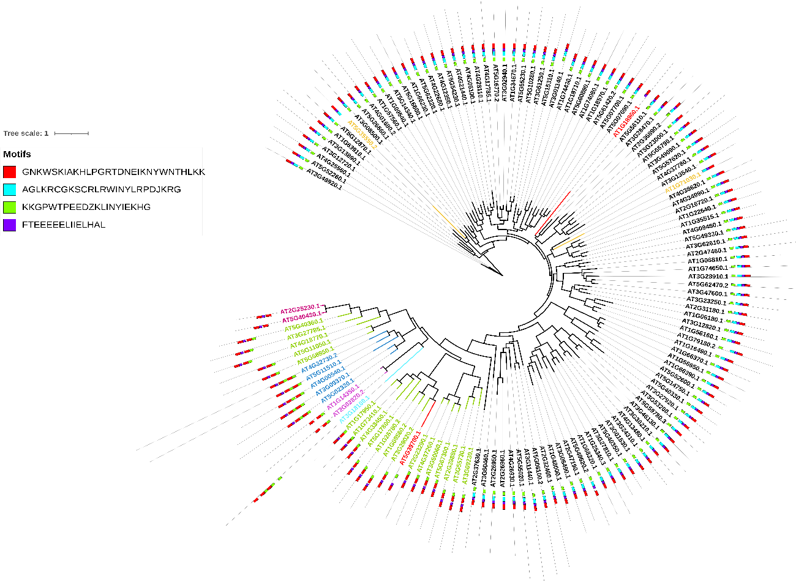

**درخت فیلوژنتیک خانواده ژنی MYB در گیاه آرابیدوپسیس**

**Phylogenetic tree of MYB gene family in Arabidopsis**

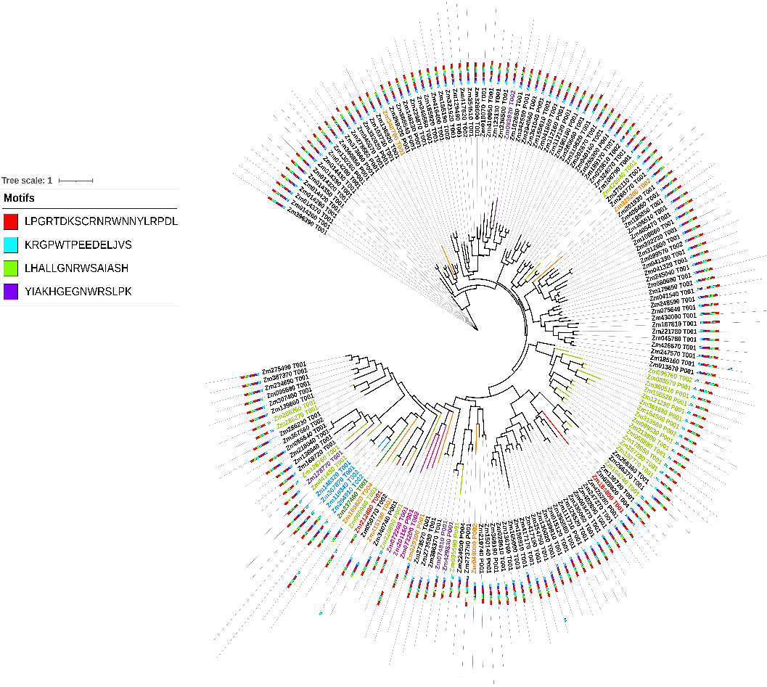

**درخت فیلوژنتیک خانواده ژنی MYB در گیاه ذرت**

**phylogenetic tree of MYB gene family in corn**

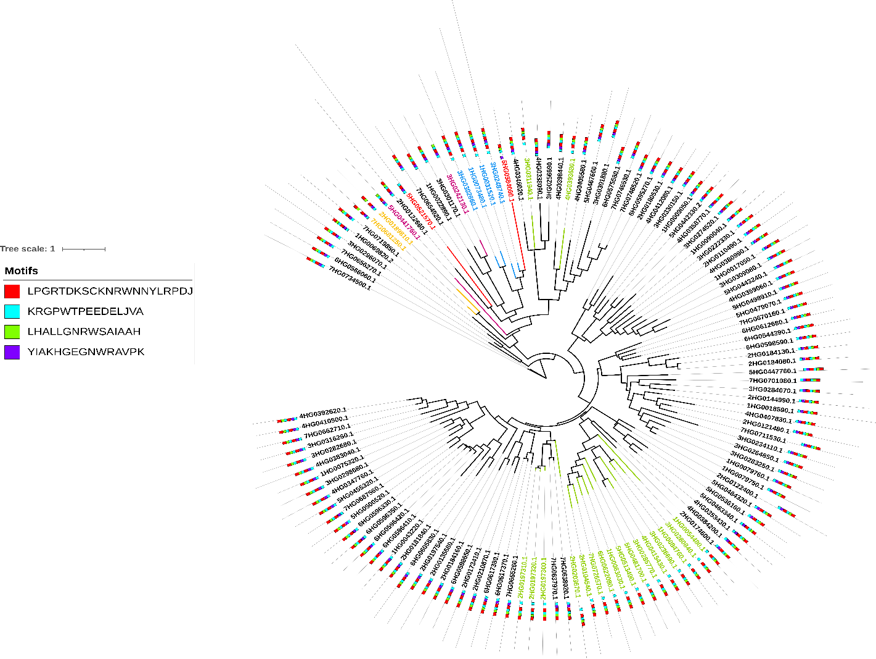

**درخت فیلوژنتیک خانواده ژنی MYB در گیاه جو**

**phylogenetic tree of MYB gene family in barley**

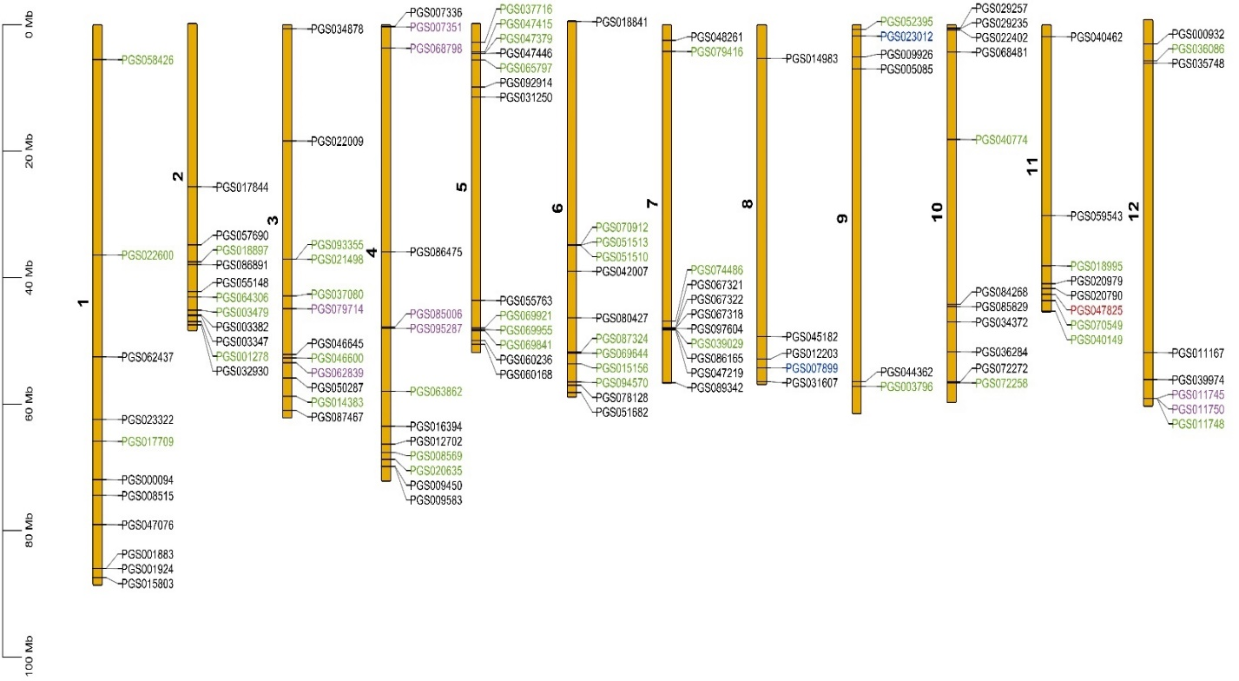

**طبقه‌بندی و مکان­یابی ژن‌های خانواده MYB روی ۱۲ کروموزوم سیب‌زمینی**

**Classification and mapping of MYB family genes on 12 potato chromosomes**

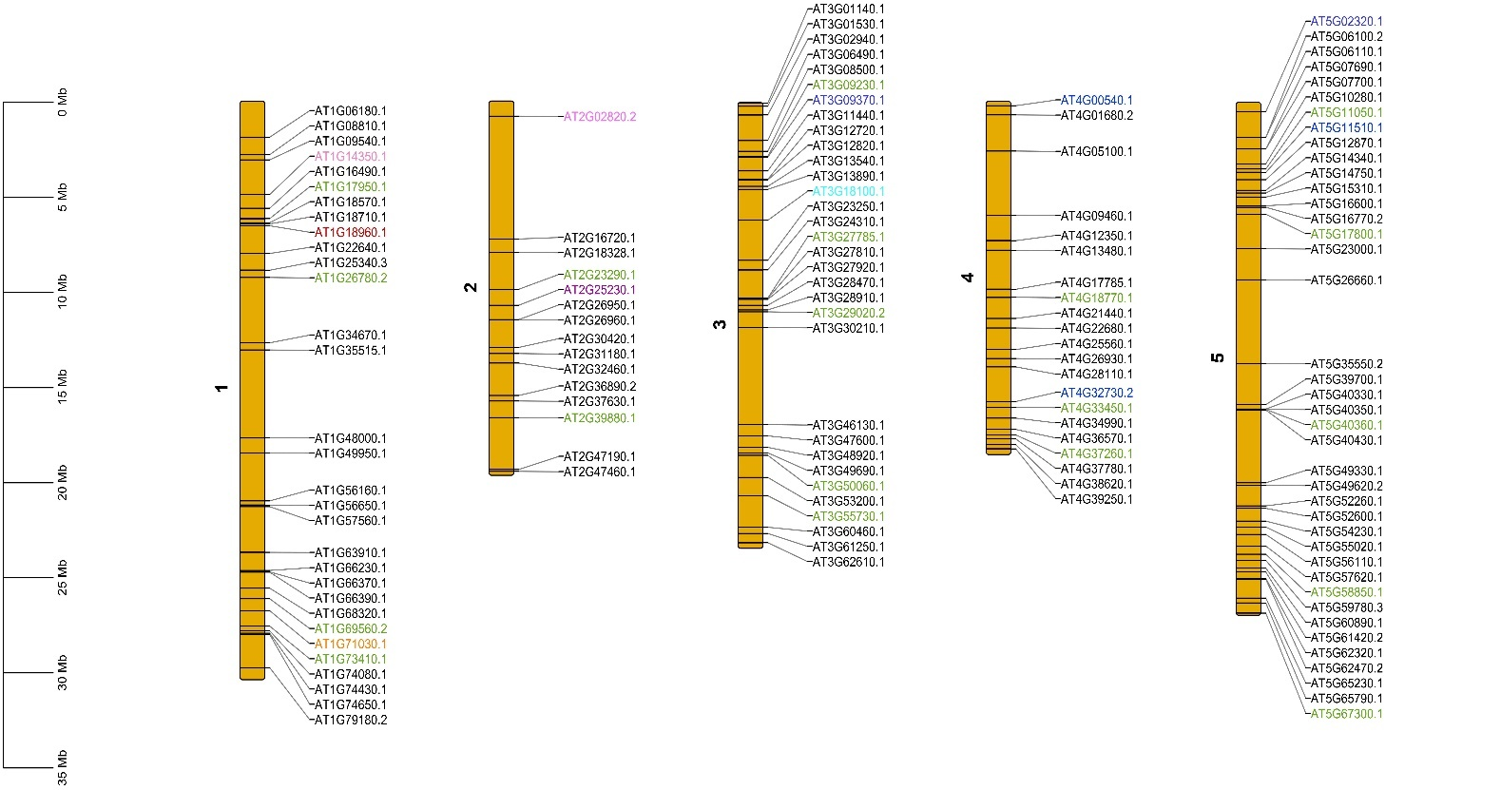

**طبقه‌بندی و مکان­یابی ژن‌های خانواده MYB روی ۵ کروموزوم آرابیدوپسیس**

**Classification and mapping of MYB family genes on 5 Arabidopsis chromosomes**

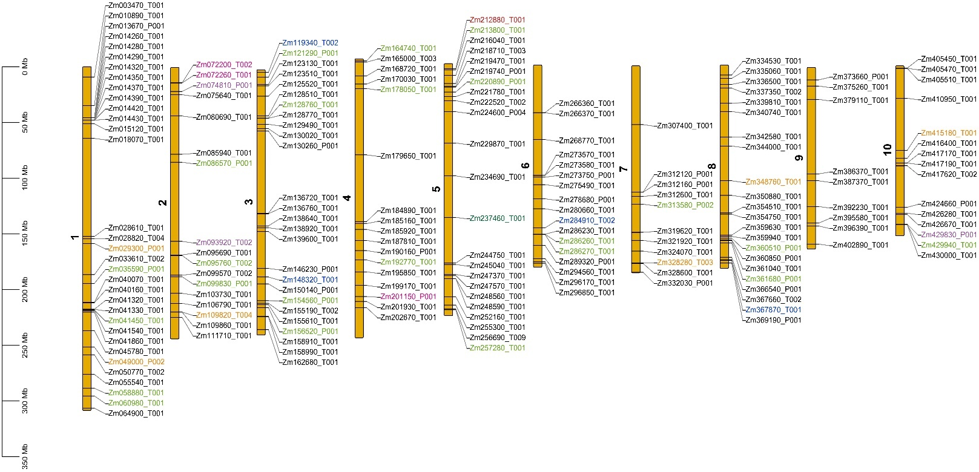

**طبقه‌بندی و مکان­یابی ژن‌های خانواده MYB روی ۱۰ کروموزوم ذرت**

**Classification and mapping of MYB family genes on 10 corn chromosomes**

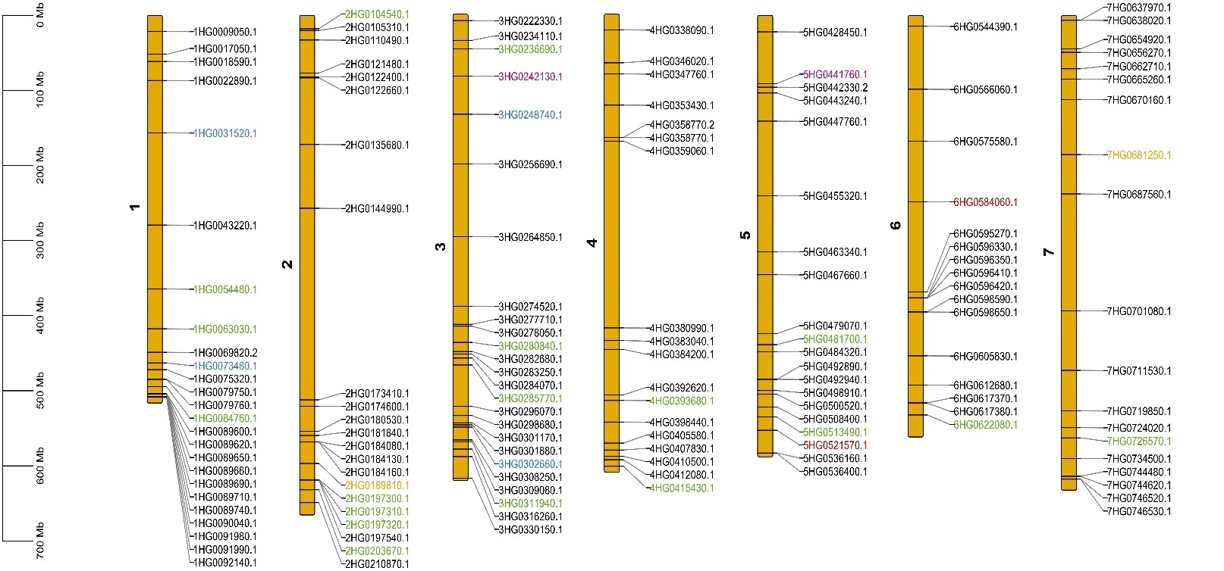

**طبقه‌بندی و مکان­یابی ژن‌های خانواده MYB روی ۷ کروموزوم جو**

**Classification and mapping of MYB family genes on 7 barley chromosomes**